Exhibition Review – Untitled by Alvin Loving

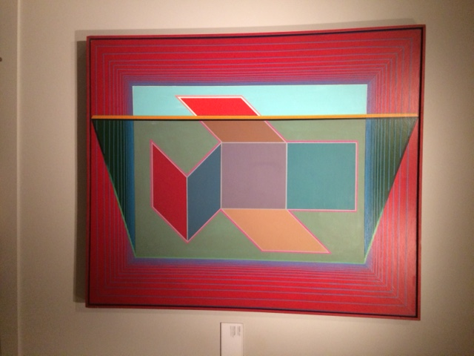

Here we have the work called, “*Untitled”* by Alvin Loving. This work was made in 1967. It is acrylic paint placed upon a canvas utilizing a color scheme of primary colors and green. This piece can be found in the Detroit Institute of the Arts’ Contemporary section, in which I visited on Nov 24, 2018. It holds similarity to his other works that utilize geometric shapes, such as *“Cube #2”* and *“Variations on a Six Sided Object”* (<https://www.artsy.net/artist/alvin-loving-jr>). Where it differs is the form of the geometric shape and what can be found in the foreground and the background.

The use of color here is really good. The red borders separated by blue make the inside of the piece stand out. Having the green tinted representation of glass over portions of the piece isn’t distracting. This also does a great job at imitating how environments are perceived through a colored screen. Although, doing so does blur what the middle and top squares’ colors are, but that can be due to my lack of being able to adequately process color.

Another thing I want to say about the use of color is the use of blue at the end of the border, towards the center of the piece. The blue becomes stronger here making it a good transition point for the background of the piece, which is a lighter mix of blue. This also works as a good transition for the green tinted glass. This is due to how the glass has a yellow colored frame. If the blue were flowing into the glass and through the yellow, the blue would mix with the yellow and create the green that can be seen on the glass.

One thing that immediately grabs my attention in this piece is the slightly opened door or window. It is very inviting. This succeeds because of the use of yellow and green, which are bright and serene colors. Another contributor to this is the flow of the piece. Directing me in a left to right motion, which would be the only way this door/window could open. It’s as though the door is opening up for me.

Another thing to note about the doorway is in how it is given perspective, in this case one-point perspective. The point is located off the piece and towards the right. You could say that the border is being given perspective as well by having the red and blue decrease in size the more it approaches the center. This time it has a perspective point at the very center of the piece. It almost gives it a repetitive pathway or hallway look, which also contributes to how welcoming the work is. Guiding me towards the focal point of the piece.

In comparison to his other work, *“Variation on a Six Sided Object*, made in the same year as the subject of this writing, the original subject is something I find to be better crafted. It utilizes a similar color scheme, but to a greater effect. The focal point’s shape isn’t as chaotic and is consistent in value throughout. Even though the other piece utilizes the same perspective for the border, it isn’t as welcoming. The other work also seems to be utilizing a light source creating dimmer colors, but the source is incomprehensible in location to the geometric shape. This isn’t a problem for the main subject of this writing. This is due to how the light source is coming from directly in front of the picture and in the direction from where we view the painting. The work in question is much easier to parse and understand.

I find this piece by Alvin Loving to be very well crafted. The use of color and perspective is very inviting and helps guide my eyes towards the focal point of the work. I really like the partially opened door/window. It creates a good effect to help make the piece not so simplistic. The only issue I have is how the green tinted glass hurts my capability to understand the colors of the middle and top squares. I can’t tell if they are supposed to be mixtures of blue or if the middle square is a mixture of red, as though it is pink.

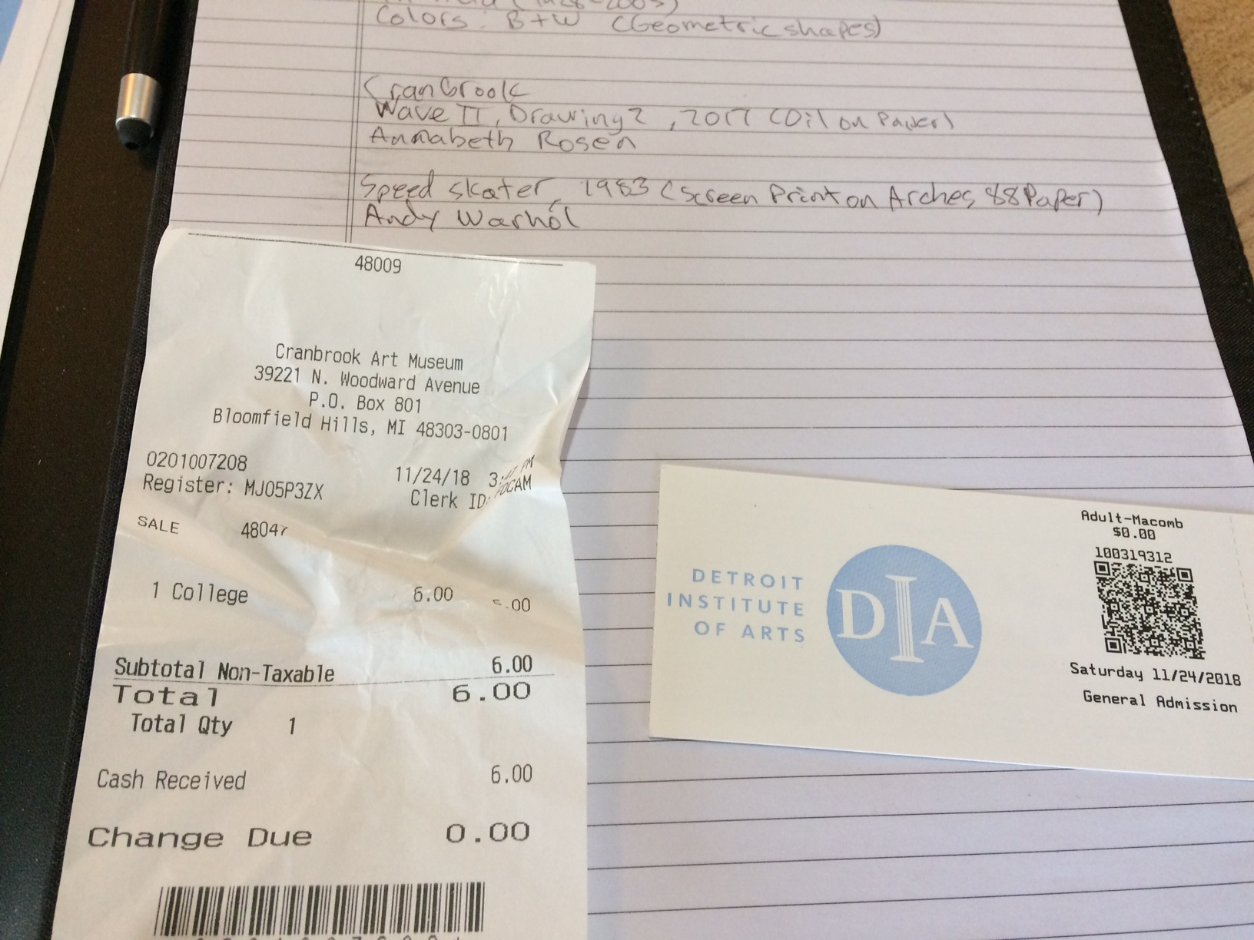

(The receipt is for the Cranbrook Art Museum, another gallery I visited for this review)